
Sri Lanka Institute of Information Technology
Milestone 02
Human Computer Interaction – IT3060
Year 3 Semester 2
Project Title | Home Service App
Group ID | WE_33
Group Name | HomeServices
Assignment 02 - Report

Contents
Workload Distributaion 3
Requirement to interface traceability 4
Sketches Variants (type 1) 6
Wireframes 6
Low-Fidelity Prototypes 7
Low-fidelity prototype & validation 10
High-Fidelity Prototypes 11
High-Fidelity prototype & Validation 15
Visual Design system 15
Prototyping Tool Justification 15
User Testing Procedure 16
Time schedule (Gantt chart) 17
References 18

Workload Distribution
Member | Assigned Module / Side | Assigned User Interfaces | Documentation / Other Responsibilities
Member 1 | Admin  Service Provider | Splash / Login / Sign Up; Home; Service provider Dashboard; Admin Dashboard, Search Service providers; | Requirements Mapping; NFR Coverage; Core Screens; Sketches; Wireframes; Low-Fidelity Prototype for assigned UIs, ty Prototype Integration; High-Fidelity Design for assigned UIs, High-Fidelity Prototype Integration,Recorded Low & High Fedelity prototype Screens; Final Report Formatting & Submission
Member 2 | User | Filter Services, User Profile, Location Settings, Payment Options, Customer Reviews, Feedback and Submit Feedback | Sketches; Wireframes; Low-Fidelity Prototype for assigned UIs; High fidelity Prototypes for assigned UIs, High-Fidelity Prototype Integration
Member 3 |  |  | Sketches; Wireframes; Low-Fidelity Prototype for assigned UIs; High-Fidelity Design for assigned UIs; User Testing Support
Member 4 | User | My Booking, Rate and Review, Help and Support, Booking Details | Sketches; Wireframes; Low-Fidelity Prototype for assigned UIs; Final Prototype Integration; High-Fidelity Prototype Integration;, Service issue log

Requirement to interface traceability
Main interface Mapping.
ID | Requirement | Affected Interface | Role
FR1 | User Registration & Authentication | Registration Screen, Login Screen | Customer, Service Provider, Admin
FR2 | Profile Creation & Management | Service Provider Profile, Edit Profile, Customer Profile | Customer, Service Provider
FR3 | Service Search & Filtering | Search Screen, Filter Panel, Search Results Screen | Customer
FR4 | Service Provider Verification | Verification Screen, Service Provider Profile | Admin, Service Provider
FR5 | Service Availability & Booking | Service Provider Profile, Availability Calendar, Booking Screen | Customer, Service Provider
FR6 | Service Category & Service Management | Service Categories, Service Details, Manage Services Screen | Customer, Service Provider
FR7 | Booking Management & Status | My Bookings, Booking Details, Booking Status Screen | Customer, Service Provider
FR8 | Ratings & Reviews | Service Provider Profile, Ratings & Reviews Section | Customer, Service Provider
FR9 | Booking History | My Bookings / Booking History Screen | Customer, Service Provider
FR10 | Notifications | Notifications Screen, Dashboard | Customer, Service Provider, Admin

Decide the core screens
Customer Side | Service Provider Side | Authority Side (Admin)
Welcome / Login / Sign Up | Service Provider Dashboard | Service Provider Verification
Customer Dashboard / Home | Create / Edit Service Provider Profile | Service Provider Profile Review
Search Services / Providers | Manage Services | Manage Service Providers
Search Results | Service Availability Management | Manage Service Categories
Filters | Booking Requests | Manage Bookings
Service Categories | Booking Management | Reported Issues
Service Details | Calendar / Working Schedule | Feedback Management
Service Provider Profile | Service History | Manage Ratings & Reviews
Availability & Booking | Ratings & Reviews | System Monitoring
My Bookings / Booking History | Profile / Account | Admin Profile / Account
Notifications | Notifications | Notifications
Ratings & Reviews | Report / Feedback | Reports / Feedback
Profile / Account | — | —

Non-functional requirements coverage
NFR | Quality | How the UI addresses it
NFR1 | Usability | Provides simple navigation, clear labels, consistent layouts, and an easy service search and booking flow so customers can complete tasks without assistance.
NFR2 | Performance | Uses simple and focused interfaces for service search, filtering, and service details so users can quickly find suitable home service providers and services.
NFR3 | Security & Privacy | Provides secure login and controlled access to customer and service provider information while avoiding unnecessary exposure of personal details.
NFR4 | Reliability & Availability | Provides clear system feedback, loading states, booking confirmations, and error messages when services or actions are temporarily unavailable.
NFR5 | Scalability | Uses a consistent interface structure and reusable UI components, so additional service providers, services, categories, and system features can be added without major visual changes.
NFR6 | Compatibility | Uses responsive layouts so the Home Service interfaces can be accessed effectively on both computers and mobile devices.
NFR7 | Maintainability | Uses consistent navigation, layouts, and reusable interface components, making the UI easier to update and maintain as new services and features are introduced.
NFR8 | Trust & Transparency | Clearly displays service provider information, available services, pricing, ratings, and reviews so customers can make informed decisions when selecting a service provider.

Sketches Variants (A and B)
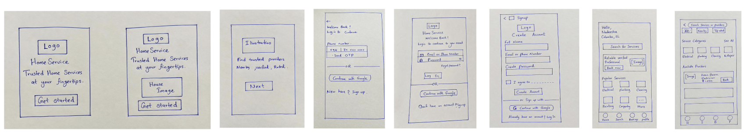

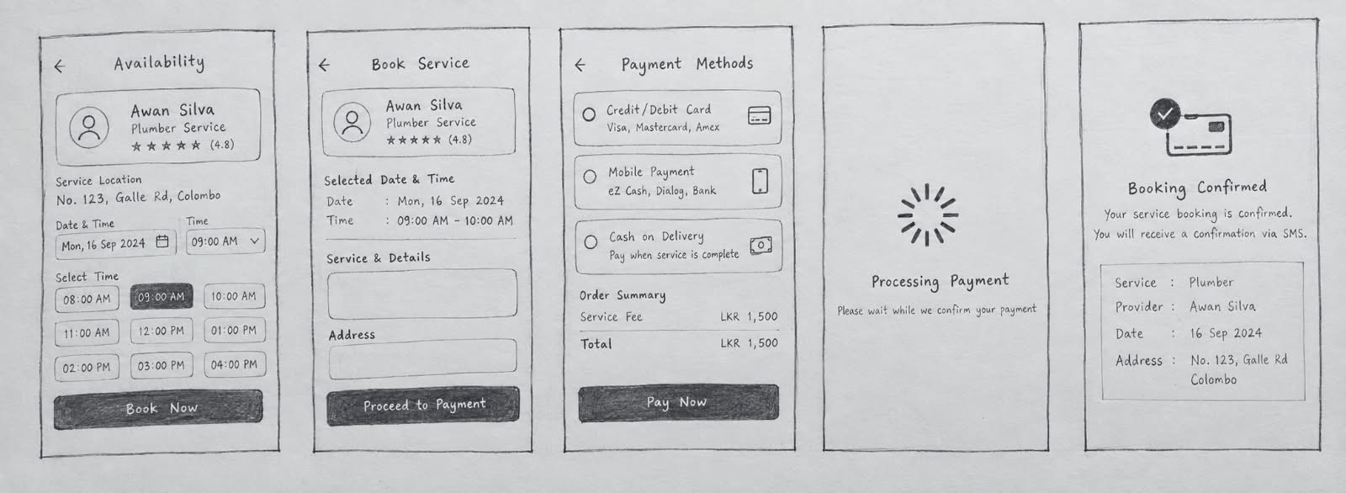
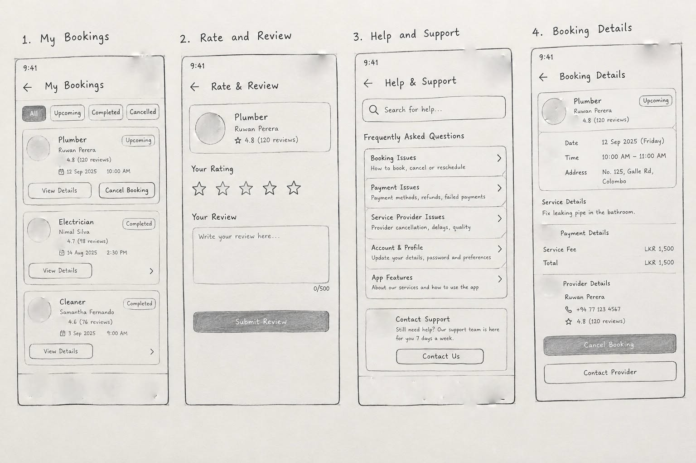

Wireframes
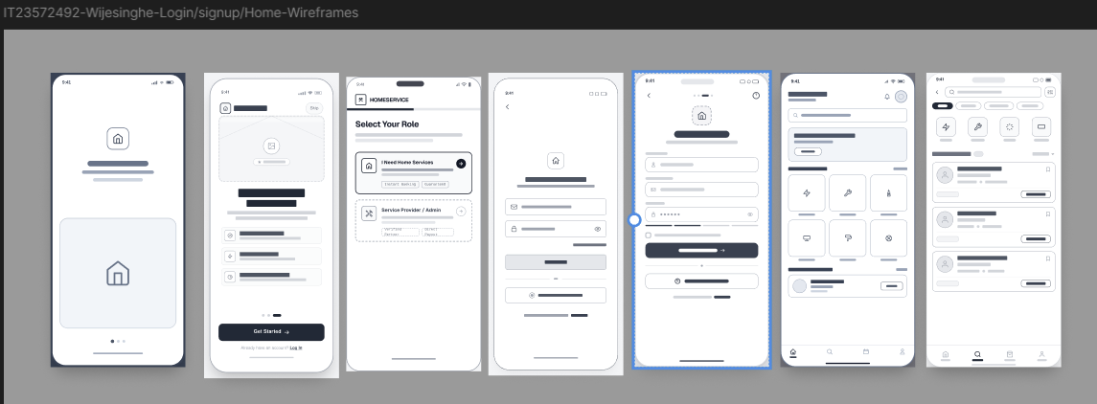
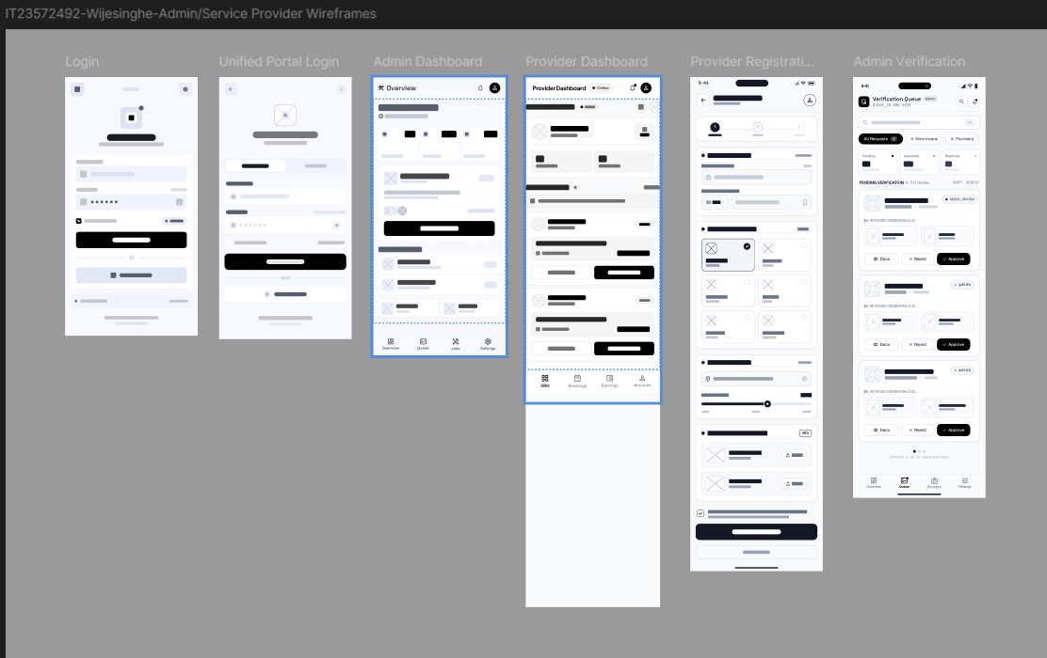

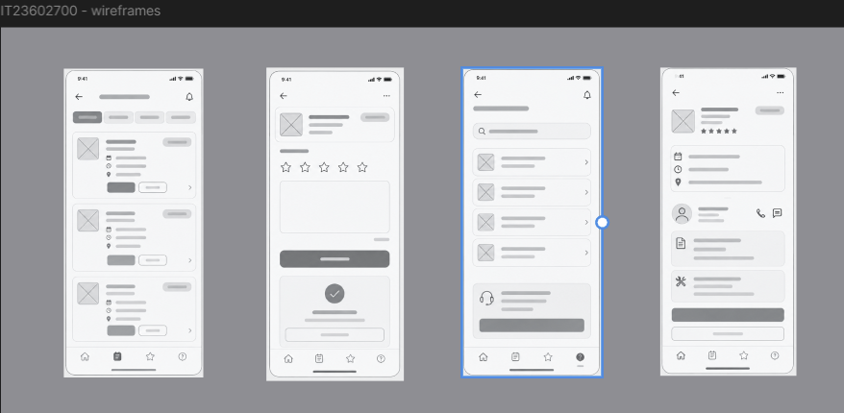

IT23603486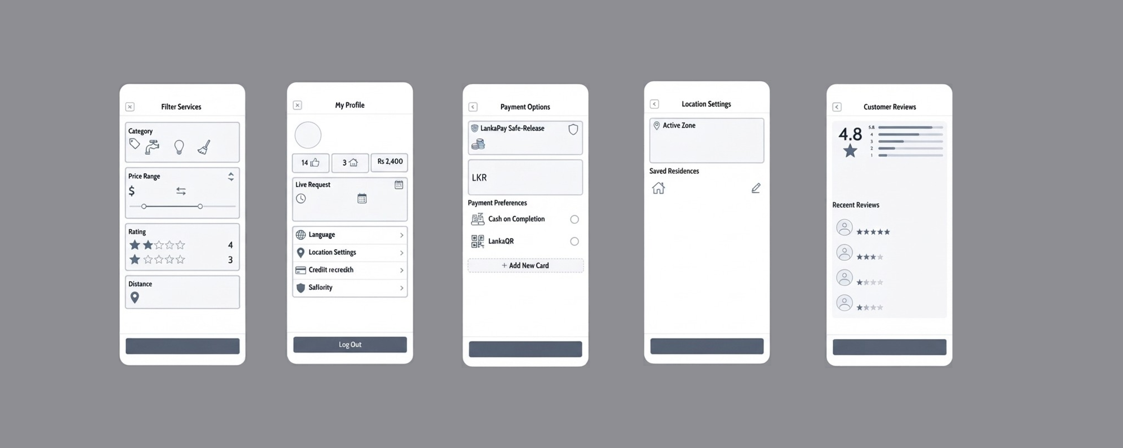

Low-Fidelity Prototypes
Customer
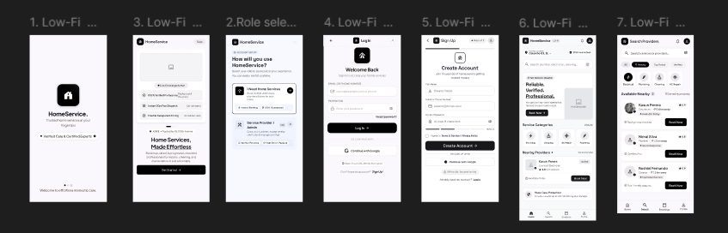
Admin module / Service Provider Module
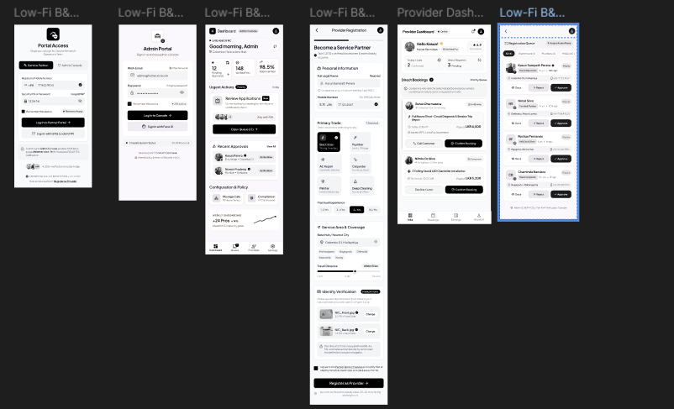

Customer – Availability, Payment
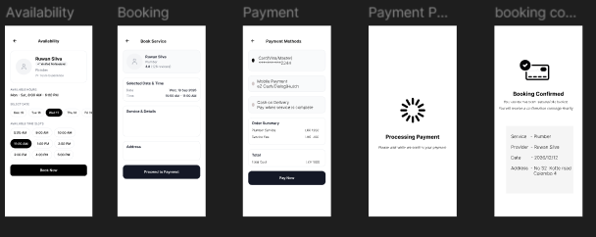
My Bookings, Rate & Reviews, Help and support and Booking details
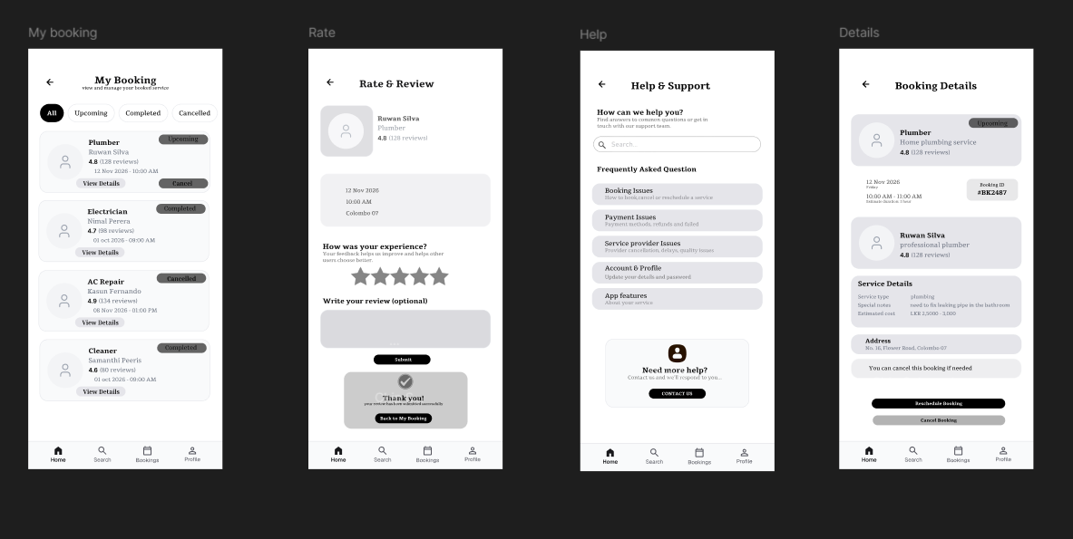

Filter Services, User Profile, Customer Reviews, Payment Options, Location Settings, Feedback
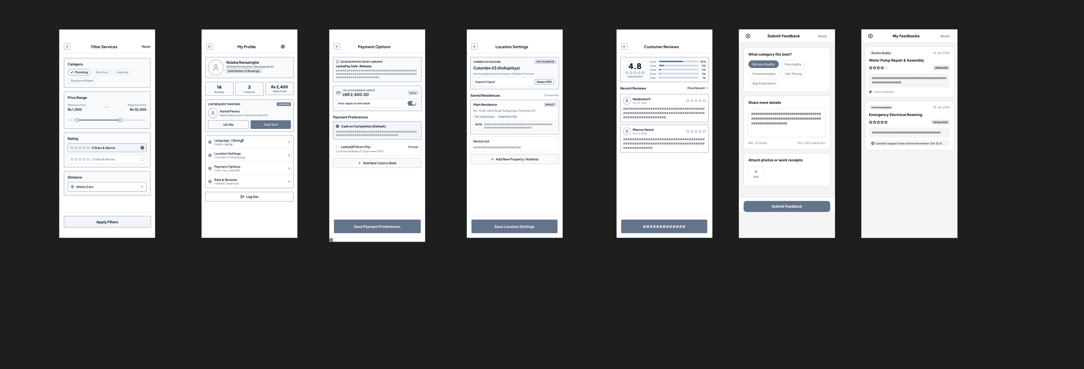

Low-fidelity prototype & validation
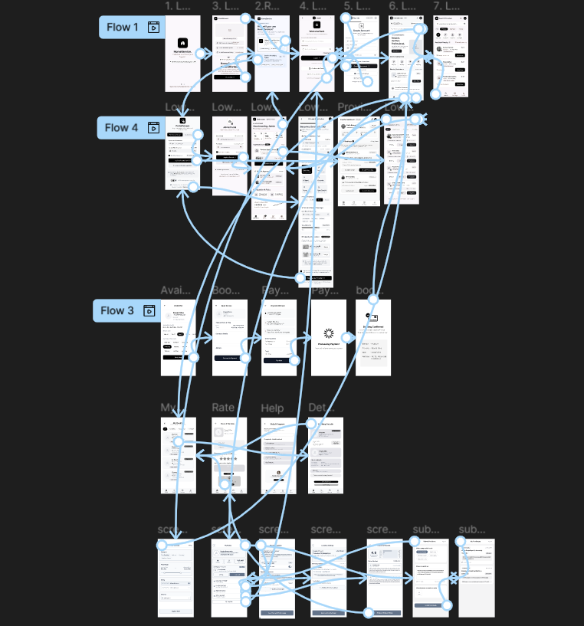

https://www.figma.com/design/ZyWuMbXWjDbQoAvpgN6XDB/IT3060HCI2026_M2_WE_33?node-id=28-129&p=f&t=QwgpOOmOWxBCkwLf-0
Validation: Validation: The low-fidelity prototype was evaluated against the functional requirements and main user flows to ensure the structure, navigation, content placement, and clarity of key actions. The review focused on service discovery, service provider profiles, service categories and details, pricing, booking, booking status, calendar and availability management, and profile management flows. This review helped refine the interface structure and navigation as needed to better organize service information, make pricing and availability clearer, and make important actions such as searching, booking and managing availability easier to identify before developing the high-fidelity prototype.

High-Fidelity Prototypes
Customer-discovery
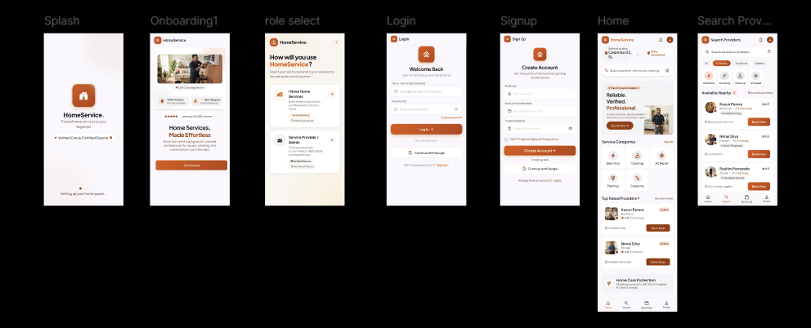
Admin module / Service Provider Module
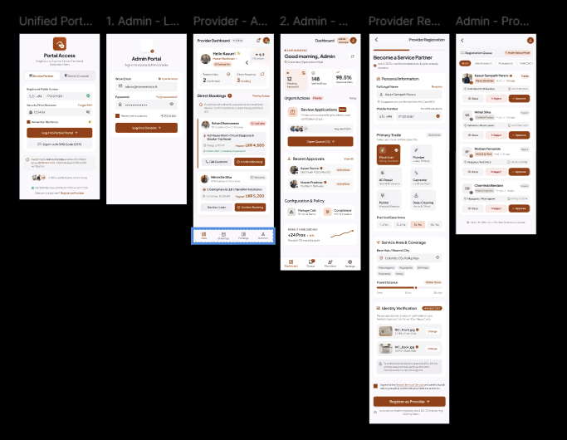
Service Provider – Availability, Payment
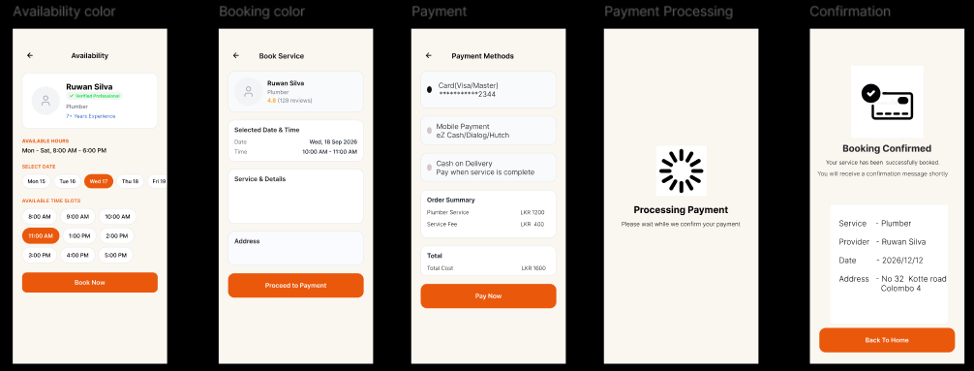
My Bookings, Rate & Reviews, Help and support and Booking details
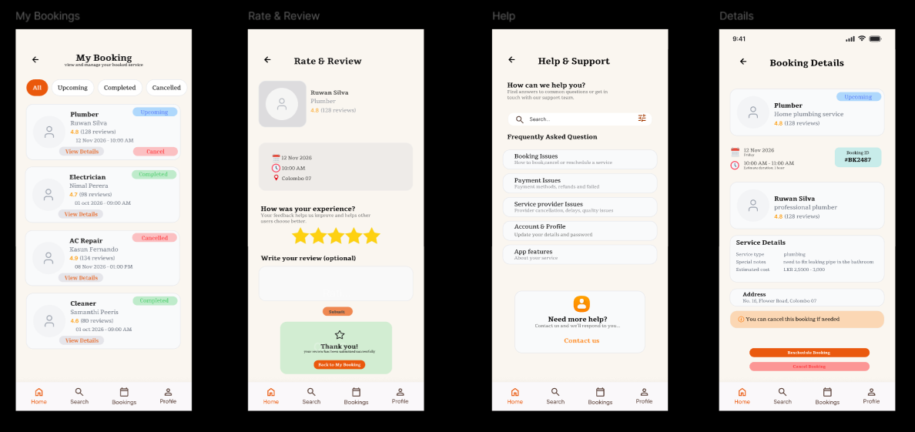

Filter Services, User Profile, Customer Reviews, Payment Options, Location Settings, Feedback
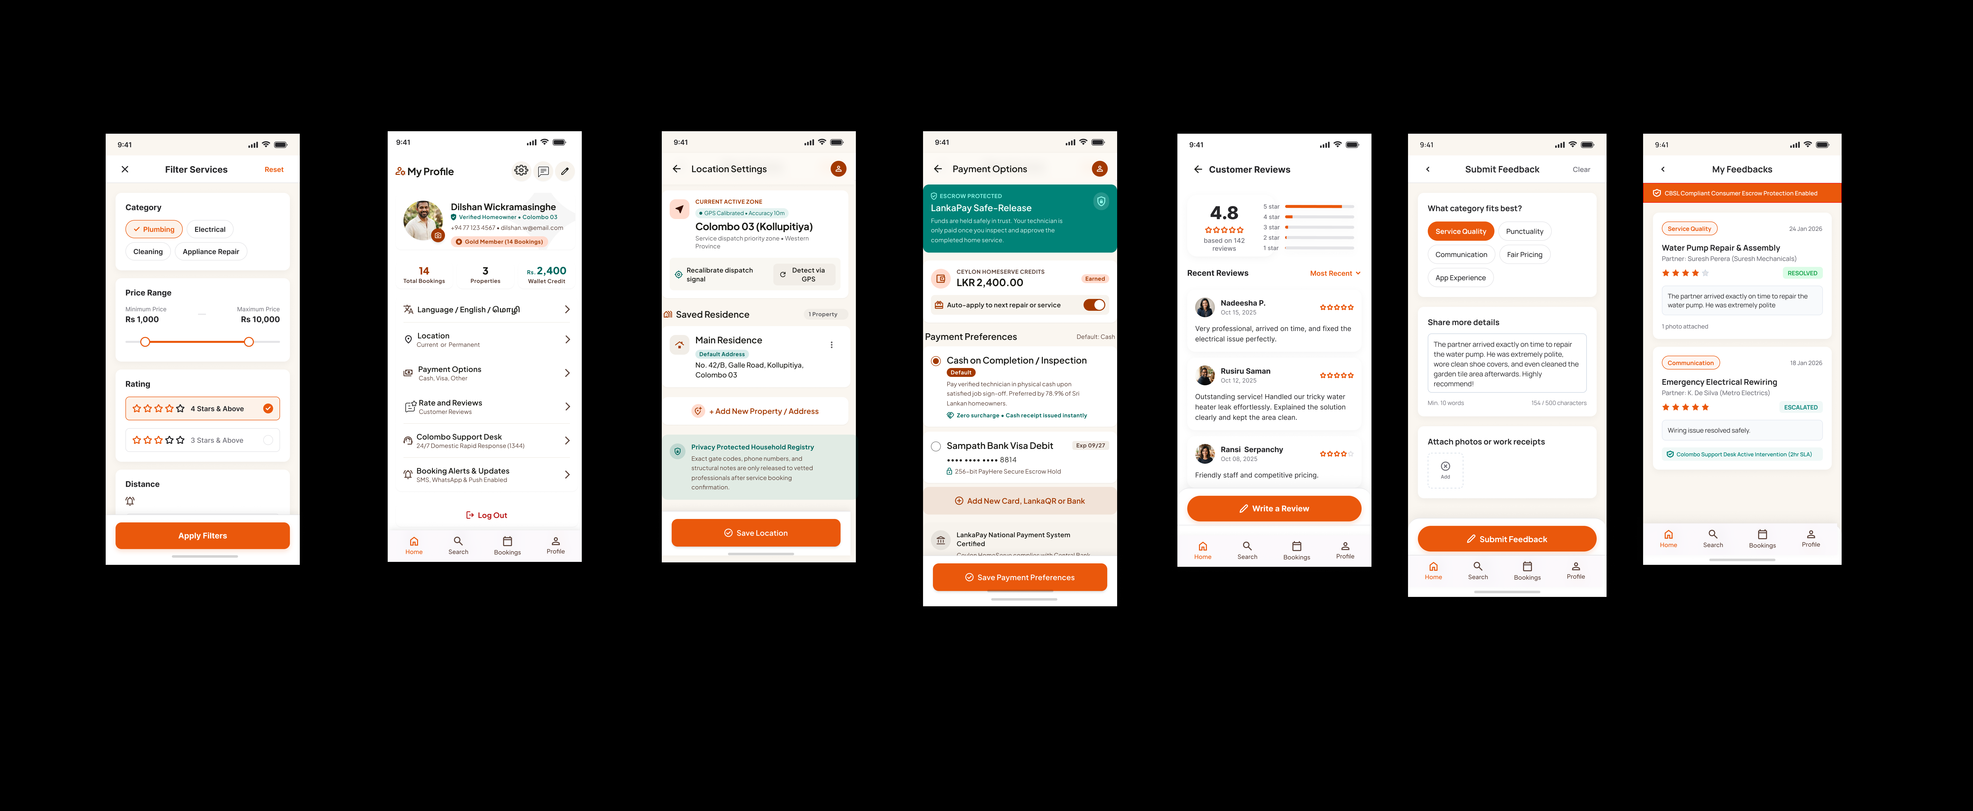

High-Fidelity prototype & Validation
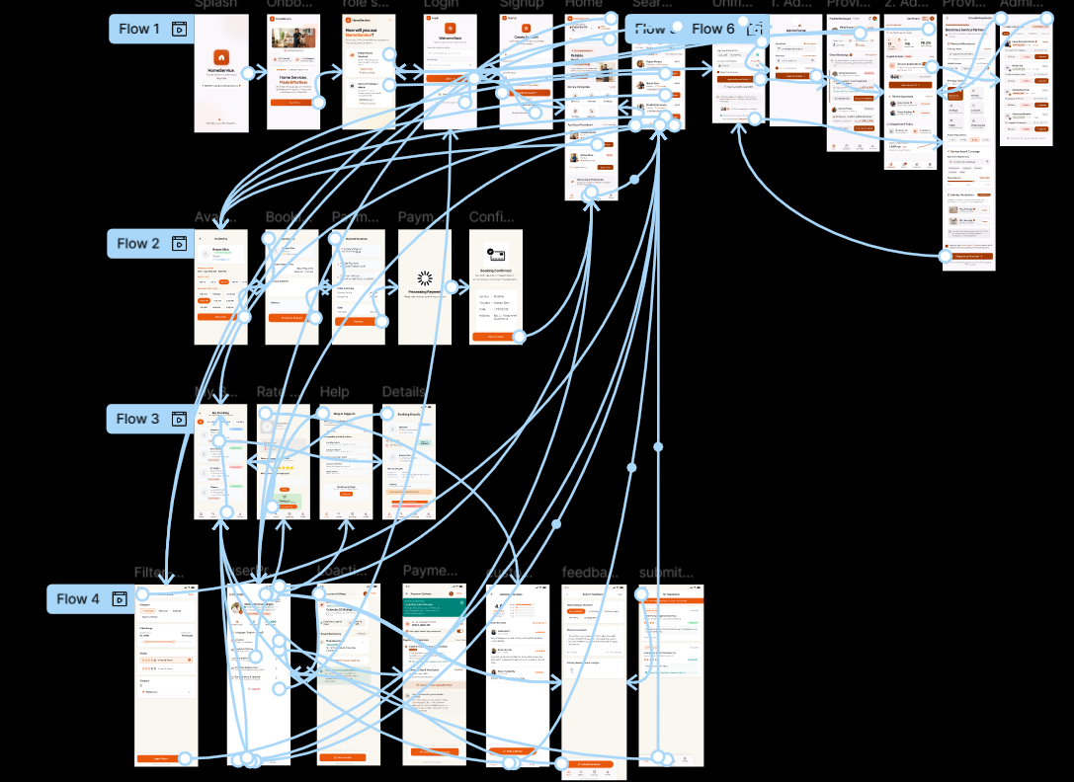
Link: IT3060HCI2026_M2_WE_33 – Figma

Visual Design system
Low Fidelity Prototype Video:LF Prototype - Recording.mp4
High Fidelity Prototype Video: HF Prototype - Recording.mp4
Five user testing Video:

Prototyping Tool Justification
We chose Figma as the prototyping tool for the Home Service system because it supports the development of both low-fidelity and high-fidelity interactive interface prototypes. It allowed the group to transform the initial sketches and wireframes into structured digital interfaces and then develop them into more detailed high-fidelity screens.
Figma also supported the creation of multiple interfaces for the different Home Service user roles, including customers, service providers, and administrators. The team was able to maintain consistency in layouts, navigation, and interface components across the different modules while developing the prototype.
The tool was also suitable for demonstrating the intended navigation and user flows of the Home Service system. This enabled the prototype to represent important processes such as service discovery, searching and filtering, viewing service provider profiles, checking service details and pricing, booking services, managing bookings, managing provider availability and working schedules, and administrative activities.
Therefore, Figma was used throughout the prototyping process, enabling the transition from sketches → wireframes → low-fidelity prototypes → high-fidelity prototypes, while also providing an interactive representation of the proposed Home Service system.

Service Issue Log

Issue ID | Interface | Usability Issue | Severity | Recommendation | Status
I01 | Search & Filter | Users found the filter options slightly difficult to identify when searching for a suitable service provider. | Medium | Make the filter options more visible and clearly labeled. | Fixed
I02 | Service Provider Profile | Service information was clear, but some users suggested organizing the service details in a more structured way. | Medium | Group service information into clear sections and improve content organization. | Fixed
I03 | Service Details / Pricing | Pricing information was available but could be more noticeable to users. | Low | Make the service price more prominent using clear placement and visual hierarchy. | Fixed
I04 | My Bookings | Booking confirmation and booking status were not sufficiently noticeable. | Medium | Use clearer status indicators and make booking confirmation information more prominent. | Fixed

User Testing Procedure
The high-fidelity TutorMate prototype was evaluated by five real or proxy participants. Participants were given a testing scenario based on a major functional requirement and asked to complete the related task with the interactive prototype. The participants were observed as they performed their task and their task completion, difficulties, confusing interface elements and feedback were recorded. We collected feedback from each participant at the end of the task via a Google Form. The testing sessions were recorded and the corresponding video evidence was uploaded to a public drive. The results were analysed to identify usability problems and opportunities for further refinement.

Tester | User roll | Testing Task | Evidence
P1 | Customer | Find a suitable Service provider for a required service using the search and filtering features and session booking.
P2 | Customer | View a service provider's profile, services, ratings and reviews to decide whether to book the service.
P3 | Customer | Select a required home service category, choose a suitable service, and view the available service details and pricing.
P4 | Customer | View the booked service details and check the appointment date, time and booking status.
P5 | Customer/ Service provider | Update service availability and working schedule using the Calendar feature.

Participant | Feedback Summary
P1- Customer | Easy service provider search and filtering; filter controls could be more visible.
P2- Customer | Service provider profiles were clear and informative; service details could be organized more clearly.
P3- Customer | Service categories and service details were easy to understand; pricing information could be made more prominent.
P4- Customer | Booking details were clear; the booking confirmation/status could be more noticeable.
P5- Customer | Availability calendar was easy to use; unavailable/selected slots could be clearer
The prototype was tested for usability with 5 participants. The results showed generally good usability across the main features of the home service system. Participants found the service search and filtering process easy to use, although the filter options could be made more visible. The service provider profiles were considered clear and informative, while the service details could be organized more clearly. Participants also found the service categories and pricing information easy to understand, with a suggestion to make pricing more prominent. The booking process and booking details were clear, although the booking confirmation and status could be made more noticeable. The service provider's availability calendar was also easy to use, while clearer visual distinction between available and unavailable time slots was suggested. Overall, the feedback indicated that the prototype was easy to navigate, with improvements mainly suggested for visibility, information organization, and clearer status indicators.
Recommendation for refinement
HomeService can be improved by making service providers availability more clear, adding an easier search function and adding real time booking and calendar functions.

Time schedule (Gantt chart)
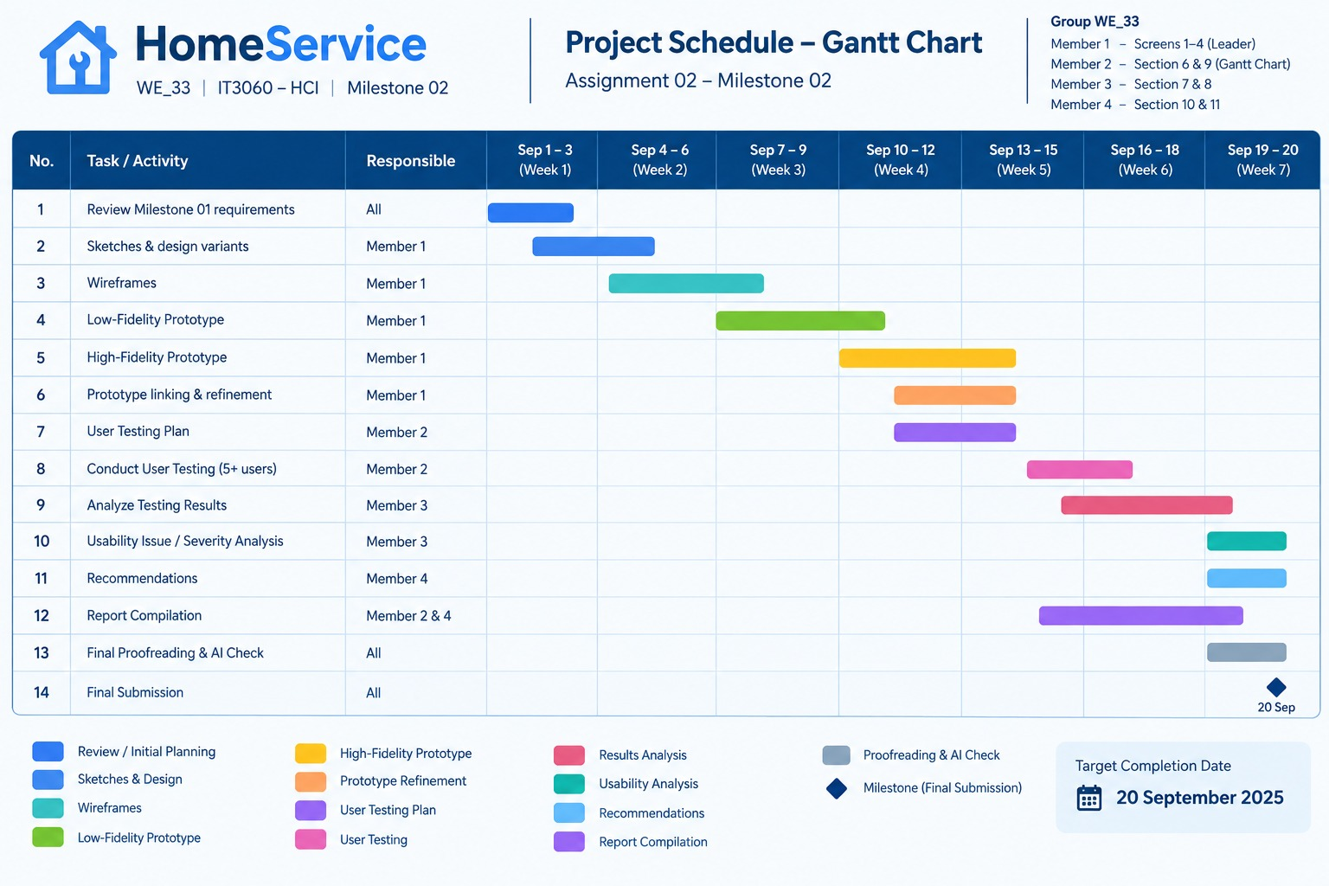

References
- Gamage, A. I. (2026). IT3060 – Human Computer Interaction: Lecture 03. SLIIT.
- Gamage, A. I. (2026). IT3060 – Human Computer Interaction: Lecture 05. SLIIT.
- Nielsen, J. (1994). Usability Engineering. Morgan Kaufmann.

Appendix

Appendix A – User Testing Evidence
- User testing task sheet
- Testing session screenshots/photos
- Participant feedback
- Completed testing forms

Appendix B – Usability Issues
- Screenshots of identified usability issues
- Severity issue evidence
- Before-and-after screenshots of improvements

Appendix C – Prototype Evidence
- Figma prototype screenshots
- Prototype interaction flow
- My Bookings screen
- Booking Details screen
- Rate & Review screen
- Help & Support screen

Appendix D – Testing Data
- Raw testing results
- Task completion records
- Participant observations
- Additional testing notes

